**Document Name:** Sprint 3 Plan

**Product Name:** MuscleMinder

**Team Name:** FitTech Innovators

**Release Name:** MuscleMinder Launch

**Sprint Completion Date**: 5/21/2024

Sprint 3 Plan

## Sprint Goal

* High Priority User Story 3.1 [8 points]: As a user, I want the app to suggest exercises when I select a muscle group so that I can effectively target that area.
* Medium Priority User Story 3.2 [5 points]: As a user, I want the ability to adjust my workout plan based on the app's recommendations for balanced muscle development.

## Sprint 3 User Stories

* High Priority User Story 3.1 [8 points]: As a user, I want the app to suggest exercises when I select a muscle group so that I can effectively target that area.
  + Task 3.1.1: Design template of all muscle pages 4
  + Task 3.1.2: Connect frontend to all backend pages 8
  + Task 3.1.3: Populate the database with our information, this includes the video for the workout and what equipment it requires. [Dumbbells, Cable, Barbell, Machine] [5 hours]
  + Task 3.1.4: Obtain the video data for each workout based on the list 2
  + Task 3.1.5: Implement filtering for workouts that require weights/equipment 4
  + Task 3.1.6: Build all of the routes for each muscle 2
  + Task 3.1.7: Setup SQL commands to query the information after selecting each workout. 8
  + Task 3.1.8: Parse backend workout data passed to the frontend and display it 4
* Medium Priority User Story 3.2 [5 points]: As a user, I want the ability to adjust my workout plan based on the app's recommendations for balanced muscle development.
  + Task 3.2.1: Improve your workout button, puts together a list of exercises that completes your workout [10 hours]
  + Task 3.2.2: Limited equipment selector. [5 hours]

**Task assignment:**

| Qays | Riksean | Safwan | Alexander | Jack |
| --- | --- | --- | --- | --- |
| 3.1.3  3.1.4 | 3.2.2 | 3.1.5  3.1.6  3.1.7 | 3.1.1  3.2.1 | 3.1.2  3.1.8 |

**Initial Burn-up Chart**

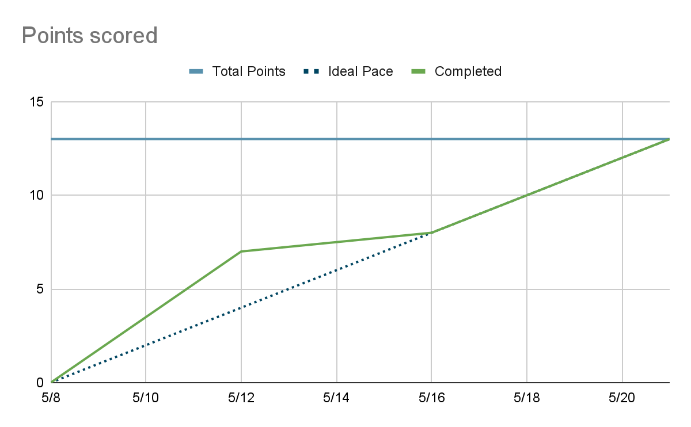

| **Titled User Stories,** | **Tasks Not Started,** | **Tasks In Progress,** | **Tasks Finished** |
| --- | --- | --- | --- |
|  |  |  | 3.1.1  3.1.2  3.1.3  3.1.4  3.1.5  3.1.6  3.1.7  3.1.8  3.2.1  3.2.2 |

**Scrum Times:**

**Monday: 1:30 pm - 2:15pm**

**Wednesday: 1:30pm - 2:30pm (TA Meeting)  
Wednesday: After TA meeting**

**Saturday: 1:00pm - 2pm**